**JS Applications Exam Retake – Our Luxury Cars**

**Environment Specifics**

Please be aware that every JS environment may **behave differently** when executing code. Certain things that work in the browser are not supported in **Node.js**, which is the environment used by **Judge**.

The following actions are **NOT** supported:

* **.forEach()** with **NodeList** (returned by **querySelector()** and **querySelectorAll()**)
* **.forEach()** with **HTMLCollection** (returned by **getElementsByClassName()** and **element.children**)
* Using the **spread-operator** (**...**) to convert a **NodeList** into an array
* **append()** (use only **appendChild()**)
* **prepend()**
* **replaceWith()**
* **replaceAll()**
* **closest()**
* **replaceChildren()**
* Always turn the collection into a **JS array** (forEach, forOf, et.)

If you want to perform these operations, you may use **Array.from()** to first convert the collection into an array.

**In this exam, you are expected to exclusively utilize JavaScript without relying on external frameworks like React, Vue, or Angular to tackle the given challenges.**

You are assigned to implement a **Web application** (SPA) using JavaScript. The application should dynamically display content, based on user interaction and support user profiles and CRUD operations, using a REST service.

1. **Overview**

**Implement** a front-end app (**SPA**) for creating and managing **cars records**. The application allows visitors to browse through the **Our Cars** catalog. Users may **register** with an **email** and a **password** which allows them to **create** their own car records info. Car authors can also **edit** or **delete** their own publications at any time.

1. **Technical Details**

You are provided with the following resources:

* **Project scaffold**: A **package.json** file, containing a list of common dependencies. You may change the included libraries to your preference. The sections **devDependencies** and **scripts** of the file are used by the automated testing suite, altering them may result in an incorrect test operation.

To **initialize** the project, execute the command **npm install** via the command-line terminal.

* **HTML** **and CSS files**: All views (pages) of the application, including **sample** user-generated **content**, are included in the file **index.html**, which links to CSS and other static files. **Each view is in a separate section** of the file, which can be identified by a **unique class name or id** attribute. Your application may use any preferred method (such as a **templating library** or manual visibility settings) to display only the selected view and to **navigate** between views upon user interaction.
* **Local** **REST service**: A special server which contains **sample data** and supports **user registration** and **CRUD operations** via REST requests is included in the project. Each section of this document (where applicable) includes details about the necessary **REST endpoints** to which **requests** must be sent and the **shape** of the expected **request body**.

For **more information** on how to use the included server, see **Appendix A: Using the Local REST Service** at the end of this document.

* **Automated tests**: A complete test suite is included, which can be used to test the correctness of your solution. **Your work will be assessed based on these tests.**

For **more information** on how to run the tests, see **Appendix B: Running the Test Suite** at the end of this document.

**Do not use CDN** for loading the dependencies because it can **affect the tests in a negative** **way**!

**Note:** When creating HTML elements and displaying them on the page, **adhere as close as possible to the provided HTML** samples. Changing the structure of the document may **prevent the tests** from running correctly, which will **adversely affect your assessment grade**. You may **add attributes** (such as **class** and **dataset**) to any HTML element, as well as **change the "href"** attributes on links and add/change the **method** and **action** attributes of HTML forms to facilitate the correct operation of a routing library or another method of abstraction. You may also add hidden elements to help you implement certain parts of the application requirements.

1. **Application Requirements**

**Navigation Bar (5 pts)**

Implement a **NavBar** for the app:

Navigation links should correctly change the current page (view). All users can see the site **logo** that should be a link to the **Home** page as well as the navigation link to **Our Cars** page. **Guests** (un-authenticated visitors) can see the links to the **Login** and **Register** and **Search** pages. The logged-in user navbar should contain the links to the **Add Your Car**, **Search** pages and a link for the **Logout** action.

**Logged-in User** navigation example:



**Guest** navigation example:



**Home Page (10 pts)**

Implement a static **Home page** for the app using the structure for it from the given resources. 

**Login Page (5 pts)**

The **included REST service** comes with the following **premade** user accounts, which you may use for development:

**{ "email": "peter@abv.bg", "password": "123456" }**

**{ "email": "john@abv.bg", "password": "123456" }**

The **Login** page contains a form for existing user authentication. When the user provides a registered **email and the correct password**,the app should log them in the system (**if** there are **no empty fields**).

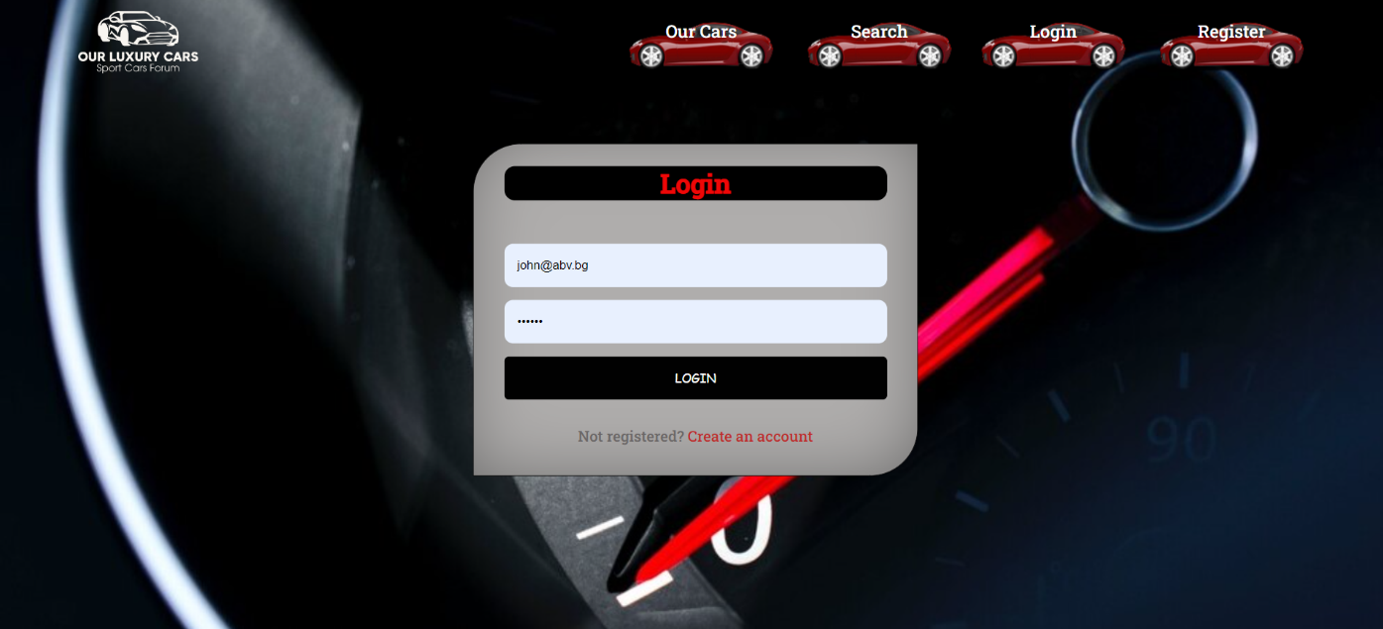

Send the following **request** to perform login:

**Method:** POST

**URL:** /users/login

The required **headers** are described in the documentation. The service expects a body with the following shape:

**{**

**email,**

**password**

**}**

Upon success, the **REST service** will return the newly created object with an automatically generated **_id** and a property **accessToken**, which contains the **session token** for the user– you need to store this information using **sessionStorage** or **localStorage** in order to be able to perform authenticated requests.

If the login was successful, **redirect** the user to the **Home** page. If there is an error, or the **validations** don’t pass, display an appropriate error message, using a system dialog (**window.alert**).

**Register Page (10 pts)**

When the user enters an **email,** a **password**, and a **password confirmation**, theapp should register a new user in the system. All fields are required – if any of them is empty or the **password** and **repeat password** doesn't match, display an error.

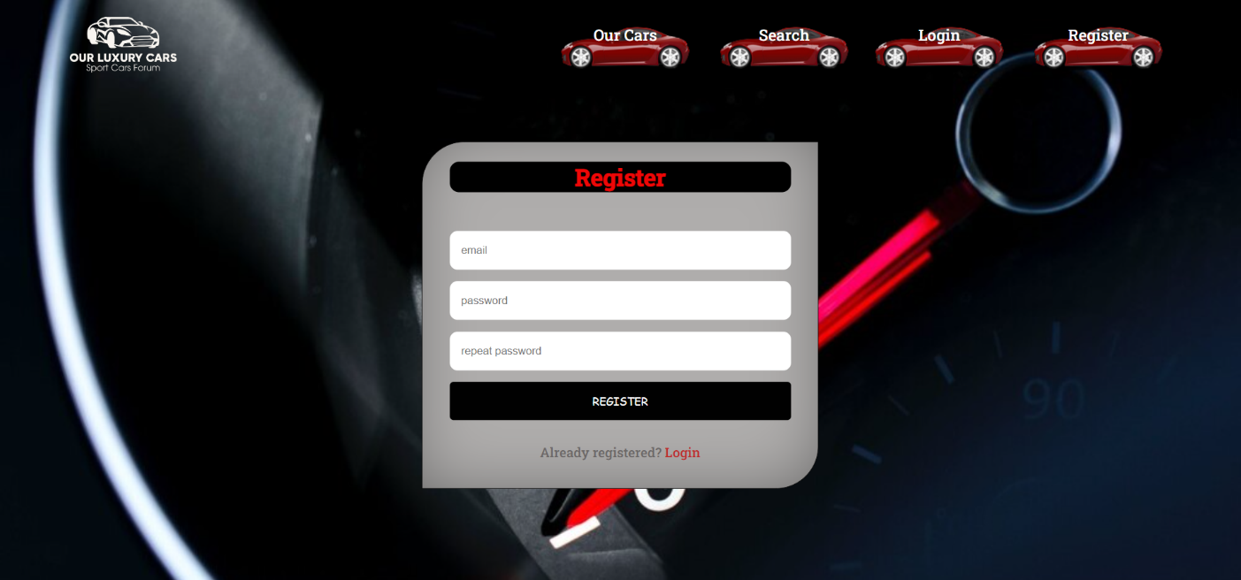

Send the following **request** to perform registration:

**Method:** POST

**URL:** /users/register

Required **headers** are described in the documentation. The service expects a body with the following shape:

**{**

**email,**

**password**

**}**

Upon success, the **REST service** will return the newly created object with an automatically generated **_id** and a property **accessToken**, which contains the **session token** for the user–you need to store this information using **sessionStorage** or **localStorage** in order to be able to perform authenticated requests.

If the registration was successful, **redirect** the user to the **Home** page. If there is an error, or the **validations** don’t pass, display an appropriate error message, using a system dialog (**window.alert**).

**Logout (5 pts)**

The logout action is available to **logged-in users**. Send the following **request** to perform logout:

**Method:** GET

**URL:** /users/logout

The required **headers** are described in the documentation. Upon success, the **REST service** will return an **empty response**. Clear any session information you’ve stored in browser storage.

If the logout was successful, **redirect** the user to the **Home** page.

**Dashboard (15 pts)**

This page displays a list of all cars in the system. Clicking on the **More Info** button in the car card leads to the details page for the selected car. This page should be visible to guests and logged-in users.

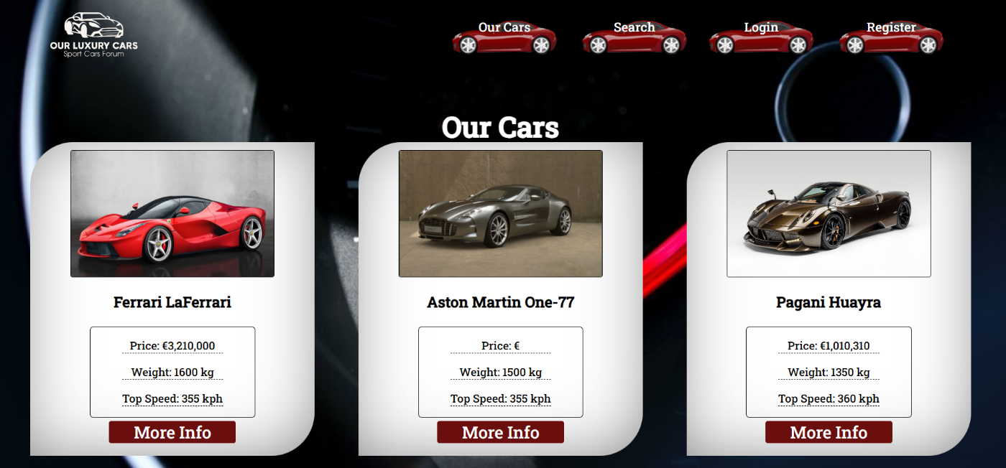

If there are **no cars**, the following view should be displayed:

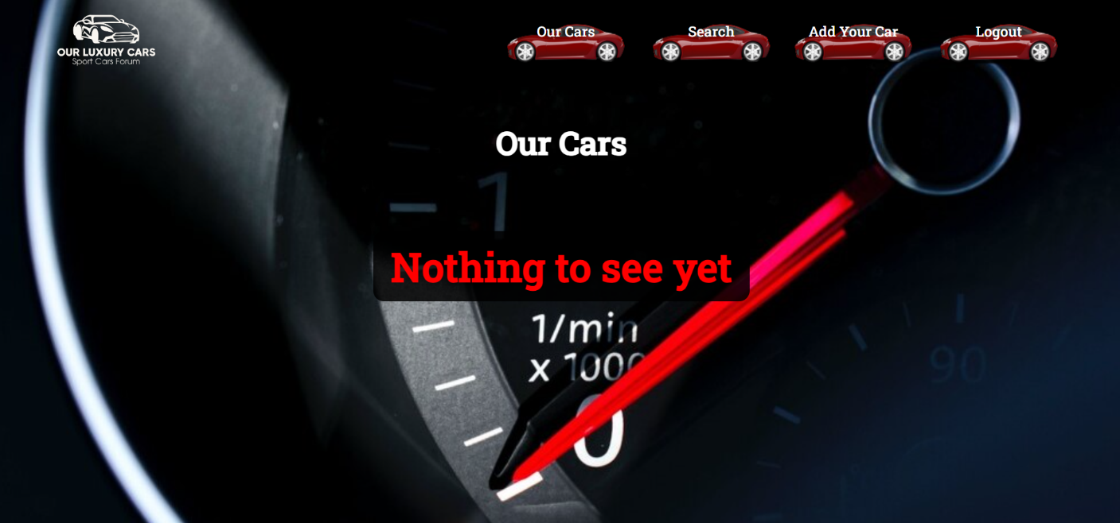

Send the following **request** to read the list of records:

**Method:** GET

**URL:** /data/cars?sortBy=_createdOn%20desc

The required **headers** are described in the documentation. The service will return an array of cars.

**Adding a New Car (15 pts)**

The Create page is available to **logged-in users**. It contains a form for adding a new car. Check if all the fields are filled before you send the request.

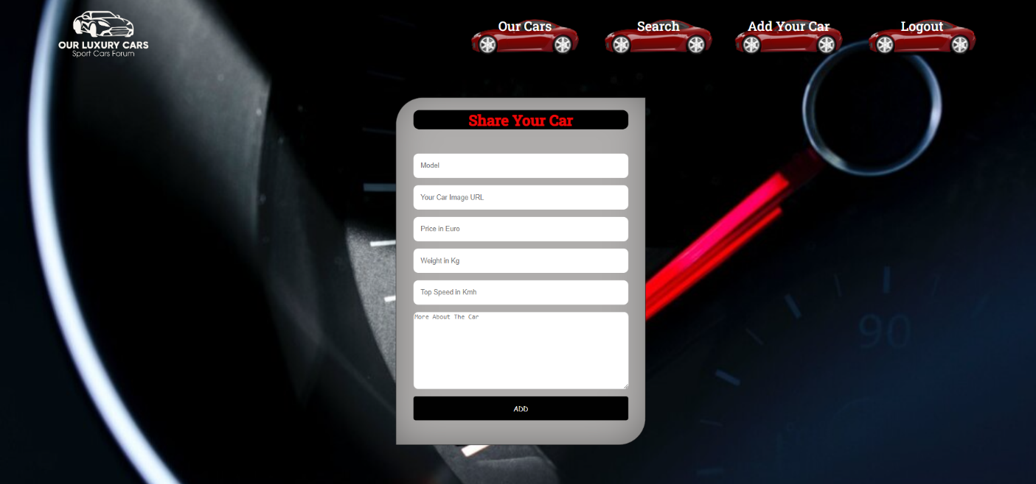

To create car record, send the following **request**:

**Method:** POST

**URL:** /data/cars

The required **headers** are described in the documentation. The service expects a body with the following shape:

**{**

**model,**

**imageUrl,**

**price,**

**weight,**

**speed,**

**about**

**}**

The required **headers** are described in the documentation. The service will return the newly created record. Upon success, **redirect** the user to the **Our Cars** page.

**Car Details (10 pts)**

All users should be able to **view details** aboutcar. Clicking the **More Info** button in a **car card** should **display** the **Details** page. If the currently **logged-in user** is the **creator**, the **Edit** and **Delete** buttonsshould be displayed. Otherwise, they should not be available. The view should look like this to the **creator** of the car record:

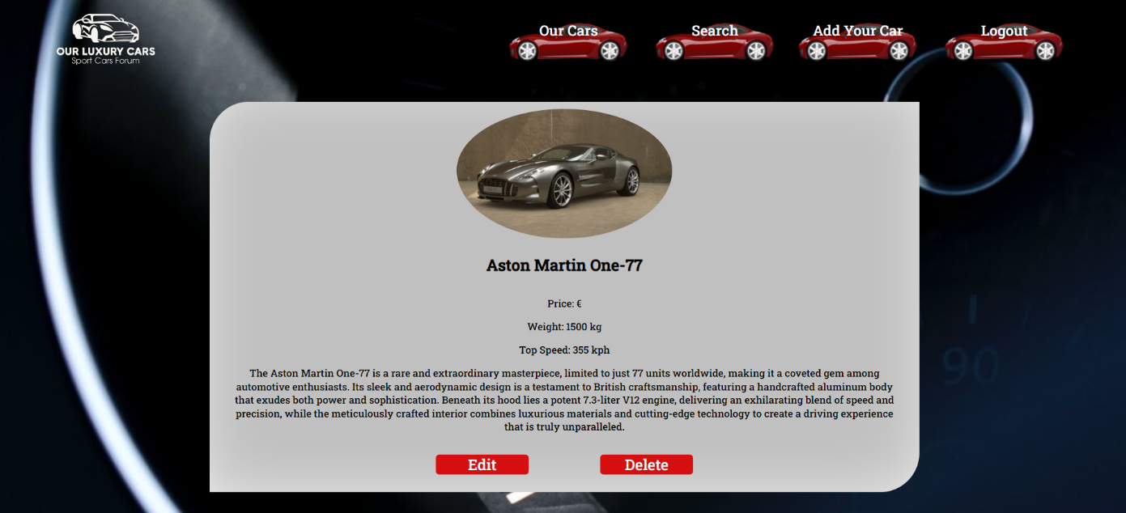

The view for **guests** and registered users who have not created the car record should look like:

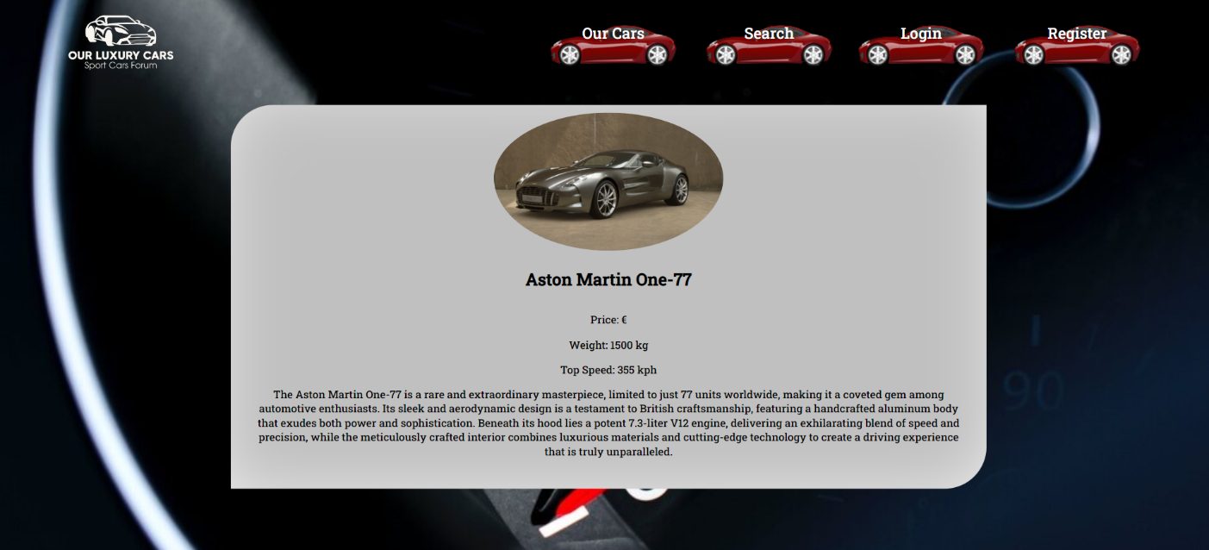

Send the following **request** to read a single car:

**Method:** GET

**URL:** /data/cars/***:id***

Where ***:id*** is the **ID** of the desired card. The required **headers** are described in the documentation. The service will return a single object.

**Editing a Car Record (15 pts)**

The Edit page is available to logged-in users and it allows authors to **edit** their **own** car records. Clicking the **Edit** link of a particular car on the **Details** page should display the **Edit** page, with all fields filled with the data for the car. It contains a form with input fields for all relevant properties. Check if all the fields are filled before you send the request.

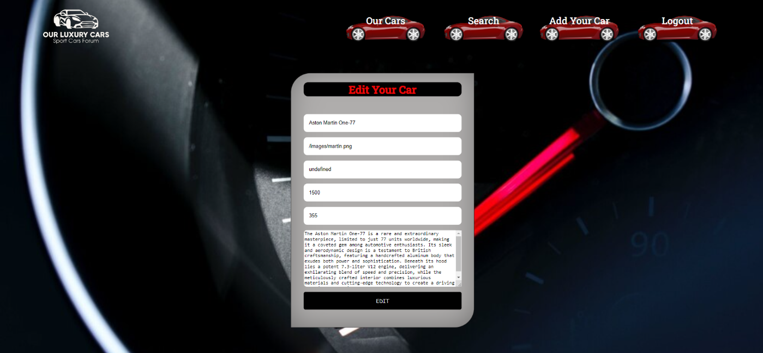

To edit a car record, send the following **request**:

**Method:** PUT

**URL:** /data/cars/***:id***

where ***:id*** is the **id** of the desired card.

The service expects a **body** with the following shape:

**{**

**model,**

**imageUrl,**

**price,**

**weight,**

**speed,**

**about**

**}**

Required **headers** are described in the documentation. The service will return the modified record. Note that **PUT** requests **do not** merge properties and will instead **replace** the entire record. Upon success, **redirect** the user to the **Details** page for the current car.

**Delete a Car Record (10 pts)**

The delete action is available to **logged-in users** for car records they have created. When the author clicks on the Delete action on any of their cars, **a confirmation dialog should be displayed**, and upon confirming this dialog, the record should be **deleted** from the system.

To delete car record, send the following **request**:

**Method:** DELETE

**URL:** /data/cars/***:id***

where ***:id*** is the **id** of the desired car. Required **headers** are described in the documentation. The service will return an object containing the deletion time. Upon success, **redirect** the user to the **Our Cars** page.

**(BONUS) Search Page (15 pts)**

The **Search page** allows both logged-in users and guests to filter cars by their model. It contains an input field and, upon submitting a query, a list of all matching cars. Check if the **field** is **filled** before you send the request. If it isn't filled show an alert message.

If you dont find some cars records, the following view should be displayed:

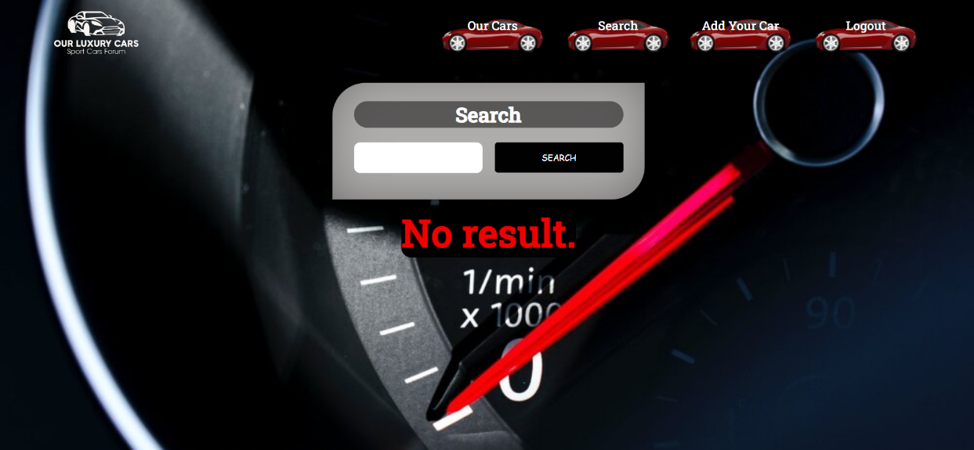

If you find cars, the following view should be displayed:

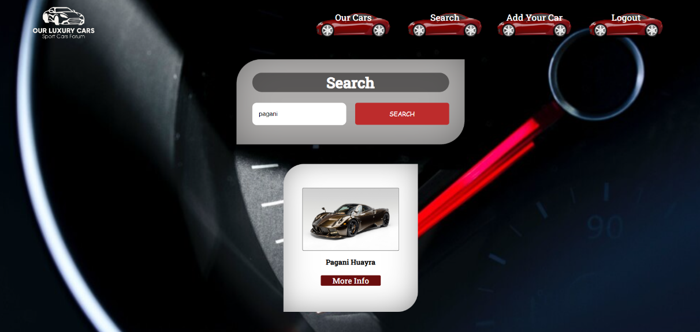

Send the following request to read a filtered list of cars by their name:

**Method:** GET

**URL:** /data/cars?where=model%20LIKE%20%22${query}%22

Where ***{query}*** is the search query that the user has entered in the input field. Required **headers** are described in the documentation. The service will return an array of cars.

1. **Subtmitting Your Solution**

Place in a **ZIP** file your project folder. Exclude the **node_modules** folder. Upload the archive to Judge.

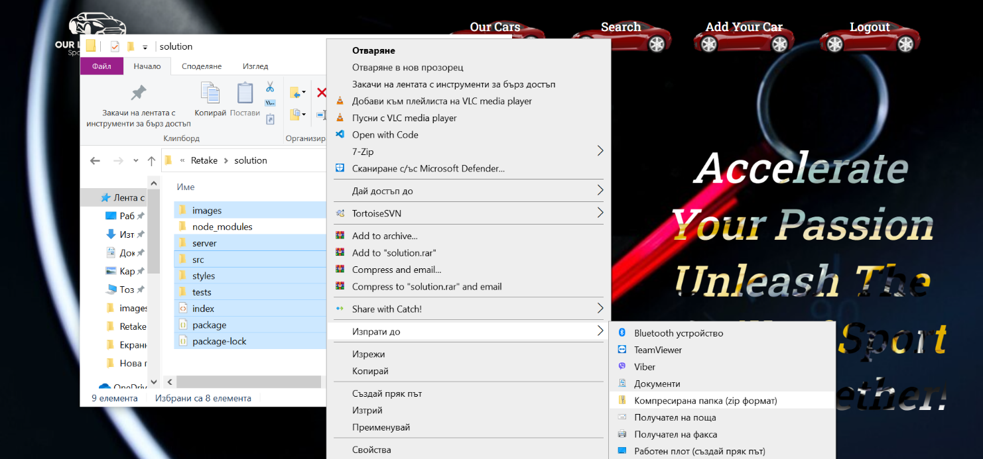

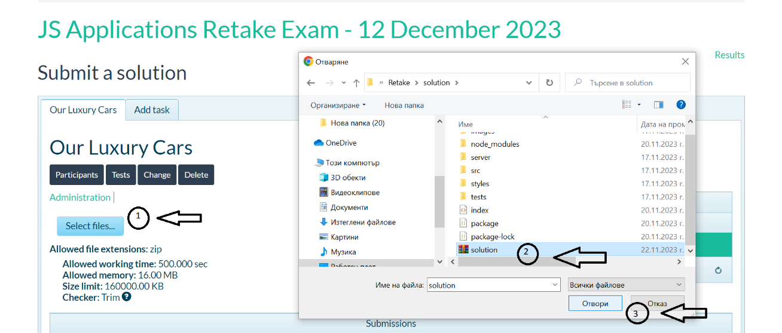

**It will take several minutes for Judge to process your solution!**

1. **Appendix A: Using the Local REST Service**

**Starting the Service**

The REST service will be in a folder named “server” inside the provided resources archive. It has no dependencies and can be started by opening a terminal in its directory and executing:

**node server.js**

If everything is initialized correctly, you should see a message about the **host address and port** on which the service will respond to requests.

**Sending Requests**

To send a request, use the **hostname** and **port**, shown in the initialization log and **resource address** and **method** as described in the **application requirements**. If data needs to be included in the request, it must be **JSON-encoded**, and the appropriate **Content-Type** **header** must be added. Similarly, if the service is to return data, it will be JSON-encoded. Note that **some requests do not return a body** and attempting to parse them will throw an exception.

Read requests, as well as login and register requests do not require authentication. All other requests must be authenticated.

**Required Headers**

To send data to the server, include a **Content-Type** header and encode the body as a JSON-string:

**Content-Type: application/json**

*{JSON-encoded request body as described in the application requirements}*

To perform an authenticated request, include an **X-Authorization** header, set to the value of the **session token**, returned by an earlier login or register request:

**X-Authorization:** *{session token}*

**Server Response**

Data response:

**HTTP/1.1 200 OK**

**Access-Contrl-Allow-Origin: \***

**Content-Type: application/json**

*{JSON-encoded response data}*

Empty response:

**HTTP/1.1 204 No Content**

**Access-Contrl-Allow-Origin: \***

Error response:

**HTTP/1.1 400 Request Error**

**Access-Contrl-Allow-Origin: \***

**Content-Type: application/json**

*{JSON-encoded error message}*

**More Information**

You can find more details on the [GitHub repository of the service](https://github.com/softuni-practice-server/softuni-practice-server/blob/master/README.md).

1. **Appendix B: Running the Test Suite**

**Project Setup**

The tests require a web server to deliver the content of the application. There is a development web server included in the project scaffold, but you may use whatever server you are familiar with. Note that specialized tools like **BrowserSync** may interfere with the tests. To initialize the project with its dependencies, open a terminal in the folder, containing the file **package.json** and execute the following:

**npm install**

Note that if you changed the section **devDependencies** of the project, the tests may not initialize properly.



**Executing the Tests**

Before running the test suite, make sure a web server is operational, and the application can be found at the root of its network address. To start the included dev-server, open a terminal in the folder containing **package.json** and execute:

**npm run start**

This is a one-time operation unless you terminate the server at any point. It can be restarted with the same command as above.

To execute the tests, open a new terminal (do not close the terminal, running the web server instance) in the folder containing **package.json** and execute:

**npm run test**



Test results will be displayed in the terminal, along with detailed information about encountered problems. You can perform this operation as many times as it is necessary by re-running the above command.

**Debugging Your Solution**

If a test fails, you can view detailed information about the requirements that were not met by your application. Open the file **e2e.test.js** in the folder **tests** and navigate to the desired section as described below.

**This first step will not be necessary if you are using the included web server.** Make sure the application host is set correctly:



The value for **host** must be the address where your application is being served. Make sure that entering this address in a regular internet browser shows your application.

To make just a single test run, instead of the full suite (useful when debugging a single failing test), find the test and append **.only** after the **it** reference:



On slower machines, some of the tests may require more time to complete. You can instruct the tests to run more slowly by slightly increasing the values for **interval** and **timeout**:



Note that **interval** values greater than 500 and **timeout** values greater than 10000 are not recommended.

If this doesn’t make the test pass, set the value of **DEBUG** to **true** and run the tests again – this will launch a browser instance and allow you to see what is being tested, what the test sees and where it fails (or hangs):



If the actions are happening too fast, you can increase the value of **slowMo**. If the browser hangs, you can just close it and abort any remaining tests by focusing the terminal window and pressing **[Ctrl+C]** followed by the letter "y" and **[Enter]**.

The final thing to look for is the exact row where the test fails:

